**ACRYLIC BASED LED LIGHTNING**

**(ABLL)**

**ABSTRACT:**

It is a acrylic sheet based led lightning for the gifts and decorations. It contains parallel connected led with operating voltage of 3V. The text or designs are plotted in the acrylic sheet by the motor axis and it placed to the controller surface. The controller surface consist of parallel connected led lights and rechargeable battery with charging port. The button is added on this device. This product is based on custom design.

**Product Components:**

3.7v lithium iron battery

6V mini solar cell

3V led lights

Recharge module

**By using Controller we make different lightning process in the acrylic sheet.**

**In this product only the Blue colour led is used.**

Product Images:

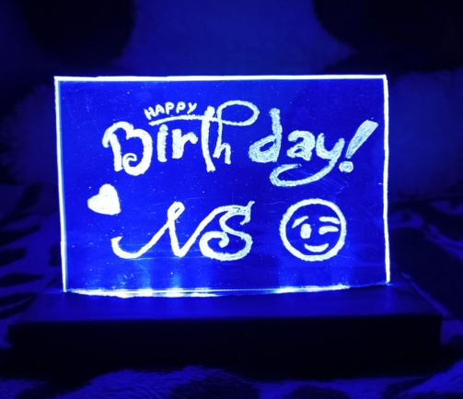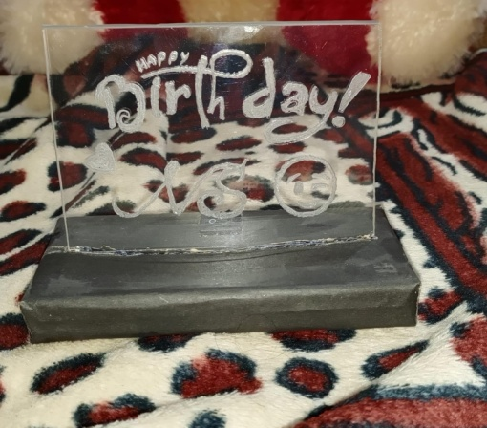  
We can customize the lights and text for this product.